**Chemical Equilibrium**

**Formative Assessment 2**

**Name: **Anne Swerkey****

**Time Allowed: 17 minutes Marks: /19**

Dichlorine monoxide (Cl2O) is a brownish-yellow gas at room temperature. It is very soluble in water and when dissolved, it reacts with water to produce weak hypochlorous acid, according to the reversible reaction below;

Cl2O(g) + H2O(l) ⇌ 2 HOCl(aq)

The solution of hypochlorous acid appears colourless. At room temperature (298 K) this reaction has a Kc value of 0.090.

H2O(l)

Cl2O

gas

A sample of Cl2O(g) was injected into a glass cylinder containing water, as shown in the diagram to the right, and allowed to establish equilibrium according to the equation above.

Several graphs have been sketched below, in an attempt to show the changes in concentration of Cl2O(g) and HClO(aq) from Time 0, when the gas was injected into the system, until equilibrium was first established at Time E1. You may assume the scales on both axes of each graph are identical.

**Graph A Graph B**

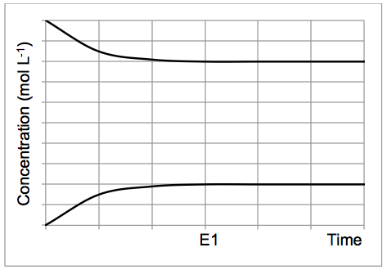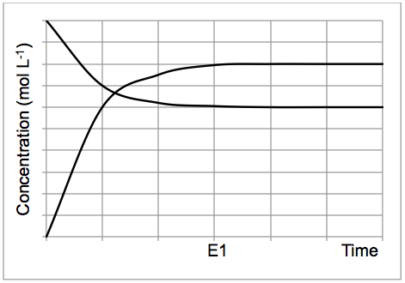

HClO(aq)

HClO(aq)

Cl2O(g)

Cl2O(g)

**Graph C**

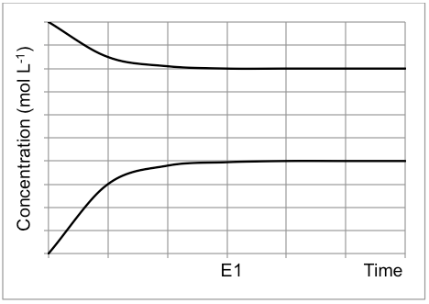

HClO(aq)

Cl2O(g)

(a) Which of these graphs (A, B or C) is **most likely** to illustrate the concentration changes that would occur, from the time the Cl2O(g) is injected into the system until the time that equilibrium is established at E1? Explain your choice below. (3 marks)

* **graph C**
* **the final [Cl2O] > [HClO], this reflects the K value being lower than 1**
* **the gradient of HClO is twice that of Cl2O, this reflects the 2:1 stoich ratio**

At Time X, the pressure on the system was then increased, as shown in the diagram below.

Cl2O(g)

H2O(l) / HOCl(aq)

Cl2O(g)

H2O(l) / HOCl(aq)

(b) State the effect this would have on the equilibrium position and describe any corresponding observations that would be made as a result of this imposed change. (3 marks)

* **equilibrium shifts right**
* **brownish yellow gas colour above solution will initially darken as pressure increased**
* **then gas colour will become a paler brownish yellow as equilibrium is re-established**

(c) Explain what would happen to both the forward and reverse reaction rates, from the time the pressure was increased until the system re-establishes equilibrium (at E2). (3 marks)

* **initially only the forward reaction rate would increase (the reverse reaction rate is initially unchanged)**
* **over time the reverse reaction rate would begin to increase (as more products are formed and can now react)**
* **the rate of the forward reaction would begin to decrease until both reaction rates are equal once again (the rate at the new equilibrium would be higher than the initial equilibrium)**

When the temperature of this equilibrium system is increased to 400 K, the value of Kc is 1.98.

(d) Explain what information this provides about the heat of reaction (ΔH). (3 marks)

* **an increased K value means an increase in product concentration since**

**K = [products]/[reactants].**

* **this means the forward reaction must have been favoured**
* **this means the forward reaction is endothermic i.e. ΔH positive**

**(a temperature increase always favours the endo direction)**

(e) Continue the graph below, showing the effect of a temperature increase on the system (imposed at Time Y) until equilibrium is re-established at E3. (You may assume water is still in the liquid state, as a result of the previous pressure increase.) (3 marks)

HClO(aq)

HClO(aq)

Cl2O(g)

**shape of two graphs (1) (-½ if HClO not double steepness of Cl2O)**

**graphs must cross over (1)**

**lines must become horizontal at E3 (1)**

(f) Explain the shift in equilibrium that occurs as a result of increasing the temperature of the system. (4 marks)

* **increasing temperature increases the average kinetic energy of the particles ½**
* **increasing temperature increases the proportion of collisions having sufficient kinetic energy to reach activation energy which increases the frequency of successful collisions**
* **as such both the forward and reverse reaction rates increase as temperature increases ½**
* **the rate of the forward endothermic reaction will increase more**
* **the rate of the forward reaction is now greater relative to the reverse reaction and so will shift the equilibrium to the right until a new equilibrium is established**

**Increasing pressure decreases distance between Cl2O particles which increases frequency of collisions with reactants and so forward reaction rate increases initially.**

**It then starts to decrease as the reactant particles are used up and more products are produced. Now the reverse reaction rate starts to increase (due to increased frequency of collisions) until the forward reaction rate is equal to the reverse reaction rate and a new equilibrium is established.**

**At new equilibrium the rate of both the forward and reverse reactions is greater than at the initial equilibrium.**